WEEK 2 ASSIGNMENT: SQL FOR DATA ANALYSIS

Question 1: Top Orders
SQL QUERY:-
SELECT
customer_name,
SUM(total_price) AS total_spending,
COUNT(order_id) AS total_orders
FROM
"SQL_Sales_Dataset_200_Rows"
GROUP BY
customer_name
ORDER BY
total_spending DESC;

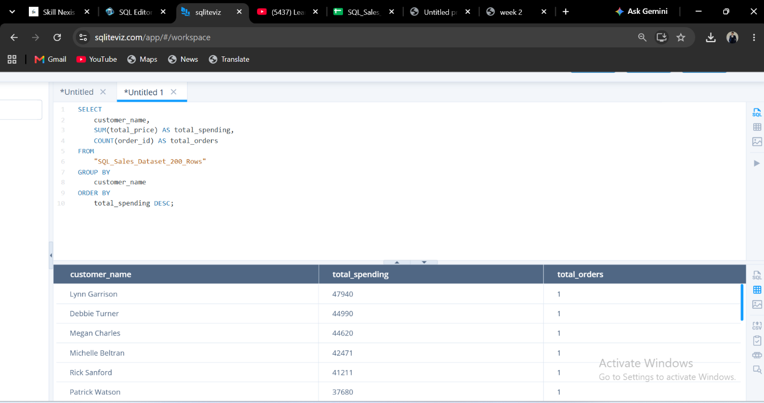
Question 2: Average Order Value
SQL QUERY
SELECT
AVG(total_price) AS average_order_value
FROM
"SQL_Sales_Dataset_200_Rows";


